# **Extensions for Working More Efficiently with VS Code**

This is a quick blog style document that will list **11** useful **VS Code Extensions that will** make your life a bit easier. *To* ***download*** *any of these extensions just go to* ***Extensions*** *tab in VS Code and* ***Search their name.***



I have divided this document in 2 sections:

1. ***Must Haves*:** Extensions that I think everyone should have.
2. ***Useful Ones:***Not necessary; I like them, you may like too!

## **Must Haves**

1. ***PyLance:***

This is a **powerful** python extension that **supercharges** your basic VS Code intellisense. It greatly **enhances** your coding **speed** & **efficiency**. Here are some of the features Pylance provides,

* Parameter suggestions
* Code completion
* Auto-imports (as well as add and remove import code actions)
* As-you-type reporting of code errors and warnings (diagnostics)
* Code outline
* Code navigation
* Type checking mode
* IntelliCode compatibility
* Jupyter Notebooks compatibility
* Semantic highlighting

1. ***Indent Rainbow:***

Simple thing but **saves minutes of debugging**. Inserts a **color** before **every indentation** making it nearly impossible to wrongly indent something.

1. ***Code Spell Checker:***

Checks the code for **spelling mistakes** in live time. Really helpful while **writing comments** or defining a **function/variable name**.



1. ***Path Intellisense:***

Sometimes we get that cumbersome **path error** and then we spend next 10-15 minutes figuring out the correct path. This extension is **solution** to this problem. **It keeps track of all the *directorie*s and *auto-suggests folders* stored at that path as soon as you *start writing the path***.

Just type “ **./ ”** and it will start suggesting paths.



1. ***GitLens:***

One Stop solution for all git related needs.

GitLens simply helps you **better understand code**. Quickly glimpse into **whom, why, and when a line or code block was changed**. Jump back through **history** to **gain further insights** as to **how and why the code evolved**. Effortlessly explore the history and evolution of a codebase.

* GitLens **supercharges** the Git capabilities built into Visual Studio Code.
* It helps you to **visualize code authorship** at a glance via Git blame annotations and code lens.
* **Seamlessly navigate and explore Git repositories**.
* Gain valuable insights via powerful **comparison** commands, and so much more.

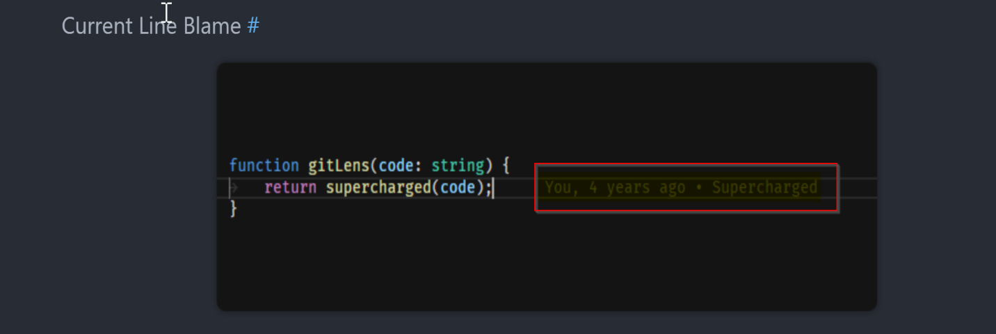

There are a l*ot more functionalities* than what I have written, make sure to **check the extension description** for more details.

## **Useful Ones**

These are the ones that I really like, so I mentioned them. These are **not mandatory**.

***1) Python Indent:***

Makes the curser stand where it should be. Intelligent curser placement tailored for python to increase coding speed.



***2) Better Comments:***

* Different comment colors can help **distinguishing normal comments** from **special comments**.
* Also, we can assign **different colors** for **different messages** like *Important, Note, Todo, Pay attention* etc.
* To use, Just add specified symbol before the comment. Ex. !,?,* etc.

***3) TODO TREE:***

* Keep all your “Todo”s in a single place.
* Imagine you are *reviewing a code* of your teammate and you *notice some error*, now instead of trying to remember it **Just add a “TODO” comment there**.
* This will automatically **get stored in a TODO** tab in VS Code.
* Now next time you want to see all the TODOs just go to the TODO tab.
* This is the **best way to keep track** of all your **unfinished tasks**.

***4) EDIT CSV:***

Edit CSVs in an Excel kind of UI inside of VS Code. Useful for quickly editing csvs.

***5) File Icons:***

Larger the project, more mess the file structure looks. File Icons Extension gives each directory & file an icon so that we can **easily identify** the **file type** and **directory structure**.

1. ***Stack Overflow View:***

And here comes, whole **stack overflow** inside of **VS code**. After installation, Press ***Ctrl + Alt + s*** to open a search box, and then **enter your search querry**. Results will be displayed inside of the VS Code itself.

1. ***Bracket Pair Colorizer:***

Colorizes matching pair of brackets, so you can now easiely identify missing brackets.

